Proudly continuing our history of academic excellence and character development: Preparing children for selective educational opportunities not only in our excellent local Grammar Schools in Southend and Essex, but also for independent schools locally and further afield.

We are a two-form entry school and work hard to ensure that all our children have equal access to every opportunity to thrive; academically, physically and emotionally. Working closely with families to know our children, we are able to challenge them in all aspects of our rich, specialist taught education and have the highest aspirations possible.

OR

At Alleyn Court Prep School we have the most fantastic opportunities awaiting primary school children with talents in academic, sporting, musical and dramatic spheres.

We are a school completely dedicated to preparing children to become the best version of themselves. 100% of our efforts are focussed on primary age children. We are experts in this department and children thrive, having been truly prepared for entrance to an extraordinary range of secondary schools.

Schools we successfully prepare children for selective 11+ entry to:

 Westcliff High School for Boys  Westcliff High School for Girls

 Southend High School for Girls  Southend High School for Boys

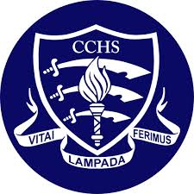Chelmsford County High School 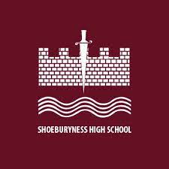 Shoeburyness High School

St Thomas Moore High School for Boys 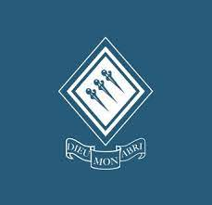 Saint Bernard’s High School for Girls

 The King John School 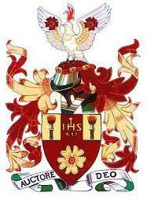 Campion School Coopers’ Coborn

Selective awards and entrance via special talents in Sports, Music and Drama

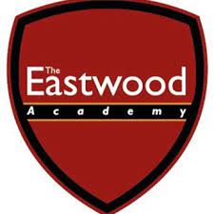 Eastwood High School  FitzWimarc School

Independent Schools acessed by children through individual interview and the ISEB (or similar) and through scholarship awards;

 New Hall School  Brentwood School 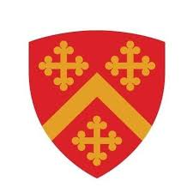Felsted School 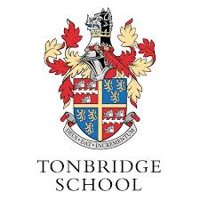Tonbridge School Haileybury School  RHS Holbrook Christ’s Hospital School  Truro School 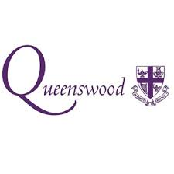 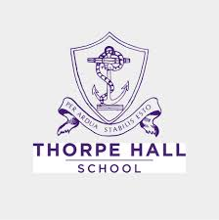  Millfield School