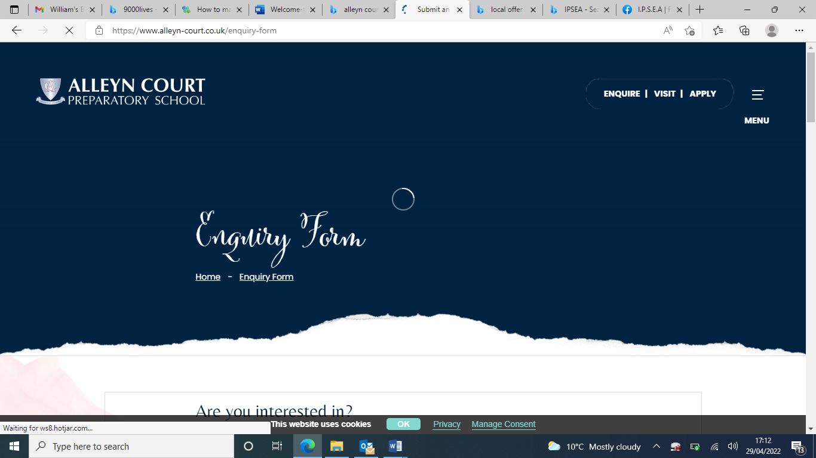

# Welcome to SEND

# at Alleyn Court

# Preparatory School

# SEND Policy & Information Report

September 2024 – September 2025

|  |  |
| --- | --- |
| **Key People** | |
| **Mrs Nicky Vangalis-Stobbs** | **Special Educational Needs and Disabilites Coordinator (SENDCo)**   * I lead and manage SEND in school.   **How to contact me**   * nvangalis@alleyn-court.co.uk * 01702 582553 |
| **Mrs Hannah Sanders** | **Head Teacher**   * I lead and manage the whole school.   **How to contact me**   * registrar@alleyn-court.co.uk * 01702 582553 |

**Welcome to *SEND* at**

**Alleyn Court Preparatory School**

This booklet unites our SEND Information Report and SEND policy. This makes it easier for parents and staff to find SEND information.

Any questions or comments, please do get in touch.

The photos of children in this report have been chosen regardless of whether they have SEND or not.

This is inclusion.

## Contents

|  |  |  |  |  |
| --- | --- | --- | --- | --- |
| 2 | What is SEND?  Our Ambitions |  | 11 | Our Team: Who’s Who |
| 3 | Types of SEND |  | 13 | Staff Training |
| 4 | Identification of pupils with SEND |  | 14 | Specialist Help |
| 5 | How We Meet Children’s Needs |  | 15 | When Children Join or Leave |
| 6 | Assess, Plan, Do, Review |  | 16 | Our School Site  Equipment for SEND Children |
| 7 | Targets |  | 17 | Your Questions Answered |
| 8 | The Role of Parents  Support for Parents |  | 19 | Looked After Children, |
| 10 | The Role of Children |  | 20 | Complaints, Exclusions,  SEND Laws and Monitoring |

## Our School

Alleyn Court is an independent preparatory school for 2 to 11 year olds in Southend-on-Sea. We currently have approximately 250 children in our 18 classes.

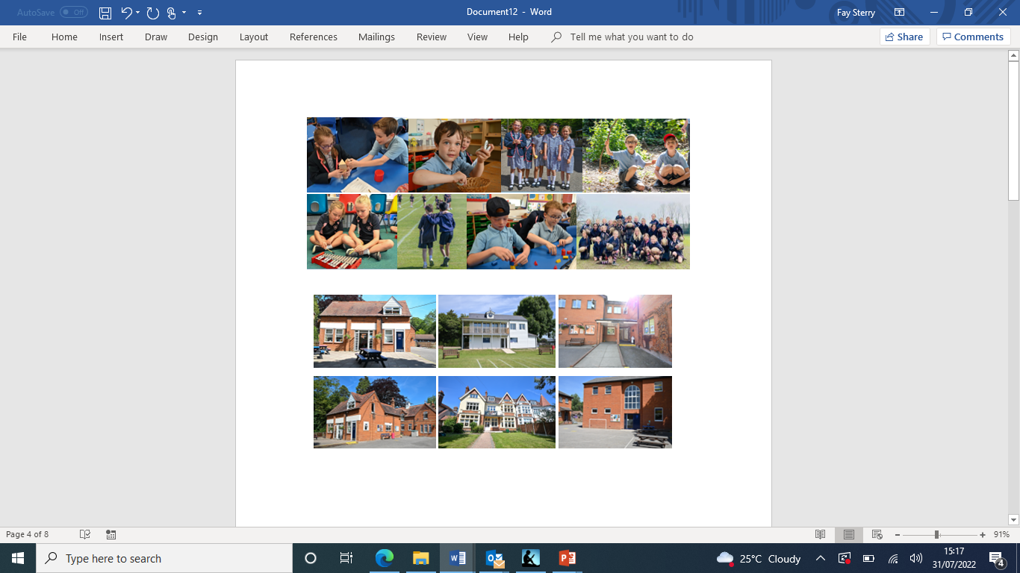

### What is SEND?

A child has SEND if they have a **learning difficulty** or **disability** that we need to make **special provision** for.

Some key terms explained:

* **Learning Difficulty:** when a child finds it harder to learn than most children do.
* **Disability (that we need to make special provision for):** something that hinders a child from using our school facilities.
* **Special provision:** is support that is extra or different to what is typically provided.

### What are our Values?

Every child with SEND can thrive. We do everything that we can to make sure that happens.

That means we:

* provide lessons that meet the needs of every child;
* make reasonable adjustments to lessons and our school environment;
* train staff to expand knowledge and expertise of SEND within the school.

### What are our ambitions for children who have SEND?

We are ambitious for all children with SEND and want them to make excellent progress.

We want to give them the knowledge and skills they need for adult life. We think about both long term and short term.

In the long term, we want our children with SEND to:

* have excellent basic skills (especially in reading, writing and maths)
* have good friends and relationships
* live a healthy and independent life in the community
* be successful in work.
* be confident and proud of their achievements and skills

## What are the types of SEND?

**The four categories of SEND**

Schools follow guidelines from the Department for Education and Department of Health’s SEND Code of Practice (2015), where SEND is categorised into four areas of need:

### 1. Cognition and Learning (C&L), including:

* + Learning difficulties;
  + Dyslexia & dyscalculia;
  + Focus, attention, or memory difficulties.

### 2. Communication and Interaction (C&I), including:

* + Autism / ASD;
  + Social communication difficulties (other than Autism);
  + Speech & language difficulties (e.g. receptive language difficulties, Selective Mutism, tongue tie).

### 3. Social, Emotional Mental Health (SEMH), including

* + ADHD;
  + Anxiety;
  + Dysregulated behaviour.

### 4. Physical / Sensory needs, including:

* + Physical needs and disabilities (e.g. Cerebral Palsy, Dyspraxia);
  + Deafness or hearing difficulty;
  + Blind or visually impaired.

Often, children have more than one type of SEND.

We welcome applications from children with all the above types of SEND. If a child has complex needs, we consider admissions on a case-by-case basis and will consult with parents prior to admission to the school. This includes an Education Health and Care plan (EHCP) consultation, where relevant. For more information on admissions for a child with SEND, please contact our Head Teacher or SENDCo.

**Identification of Pupils with SEND**

4

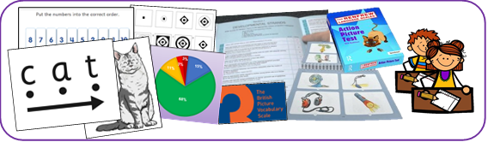

**How do we identify if a child has SEND?**

We will assess the child. This might be an assessment of reading, writing or maths. It could also be assessing a child’s social skills or emotional behaviour.

Parents may also provide us with extra information to help us identify whether a child has SEND. For example, this could be an eye clinic report about sight loss, or an Autism diagnosis letter.

Sometimes our assessment period might be quick. Usually, however, SEND only becomes clear when we assess a child over a longer period of time.

When we assess, we always look out for:

* A child making less progress than their classmates;
* A child making less progress than they did before;
* A child not closing the gap between them and their peers (despite any extra help that we have given).

Often, we will ask external professionals to assess children and give advice, with parents’ agreement.



**Is it always SEND?**

Slow progress does not always mean a child has SEND. When we are assessing whether a child has SEND, we also consider other factors such as:

* Attendance
* Issues in that child’s life (e.g. bereavement)
* Issues in school (e.g. friendships)
* Wellbeing

Often teachers address progress issues via adjustments to what is already on offer, without needing SEND provision. This is known as ‘adjustments through High Quality Teaching’.

A child does not automatically have SEND if English is not their first language (although they may have unidentified additional needs, which is masked by a language barrier).

Also, a child does not have SEND just because they were born in the summer term (and therefore started school younger than their autumn-born classmates).

**How do we meet children’s needs?**

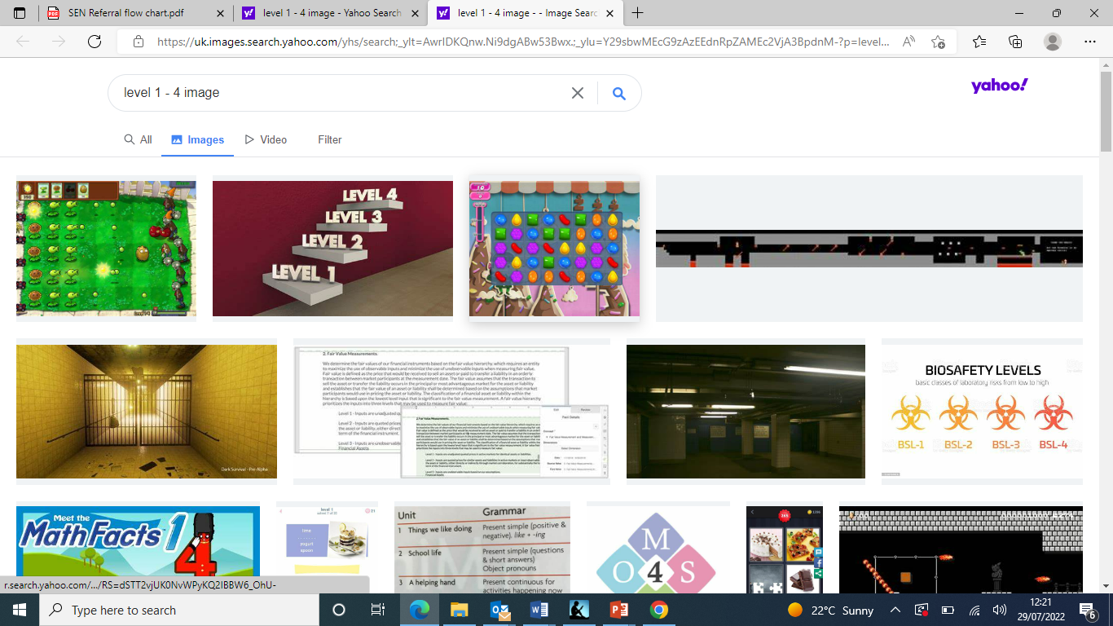

**Overview**

Children with SEND’s needs are varied. Not all children need the same level of support. Where need is higher, we usually take more action. Where need is lower, we might only need a few, hopefully temporary, adjustments.

We match the level of support to the child’s level of need. This is referred to as the ***graduated approach***.

Schools have four **levels** of support:

* **Level 1 - High Quality Teaching:** Support and opportunities that every child gets.
* **Level 2 - Pre-SEND Support:** Support & adjustments for pupils who need a little extra help. This is usually temporary
* **Level 3 - SEND Support:** Personalised support plans for children to meet higher levels of individual needs. This can be temporary or longer term.
* **Level 4 - Education, Health Care Plans:** Longer term, individual support and funding for more complex levels of SEND.

Teachers and support staff all work at all levels of support.

|  |
| --- |
| **Level 1 – High Quality Teaching**  Support is through high quality teaching lead by the class teacher. It includes: |
| * Teachers who are ambitious for all their children. * Well planned lessons that are adapted to engage all children. * Resources that help all children succeed (e.g. writing frames, number lines). * Opportunities for children to practice and use their learning in different situations. * Teachers assessing children to help them know when to move on and what to teach next. * Behaviour and reward systems that motivate children. |

|  |
| --- |
| **Level 2 - Pre-SEND Support**  For children who need extra support to catch up with their peers. It is often 1:1 or small group work, either in the classroom or elsewhere in school. For example |
| * Booster sessions for English or Maths. * 1:1 intervention or support programmes * Extra teaching assistant support in lessons. * Extra phonics sessions in a small group. * Social skills groups. * Behaviour or emotional management support. * Programmes to help fine and gross motor skills |

|  |
| --- |
| **Level 3 – SEND Support**  This means personalised SEND interventions. For example: |
| * Adapted resources and learning activities. * 1:1 Speech and Language programmes. * Social skill development programmes * An individual positive behaviour programme. * Physiotherapy or Occupational therapy work. * Tweaks to the child’s environment (e.g. a visual timetable, a calming area). * Person-centred plans (e.g. Individual Support Plan, OnePlan, Pupil Passport) |

The SENDCo keeps a record of our pupils on all levels of SEND support. We call this our *Inclusion Register.*

### Assess, Plan, Do, Review (or the ‘Graduated Approach’)

All our SEND support fits into a four-part cycle called *Assess, Plan, Do, Review.*

Assess: We determine what the child’s needs are, in consultation with parents

Plan: We set targets and decide how best to support the child to meet these targets.

Do: Staff, parents and the child follow the agreed support plan agreed.

Review: We review progress towards targets on the plan. We agree next steps.

Each cycle takes one school term and there are three cycles per year.

Sometimes this timescale is shorter (e.g. we are working on an important safety target or because the child is very young and is changing quickly).

**Targets**

**SMART Targets**

We set targets for children with SEND so that staff, parents, and children know what we are all working towards. These targets are part of a child’s Individual Support Plan or One Plan.

We often call these **SMART** targets. SMART targets are:

* **S**pecific: We say exactly what the next small step will be for the child.
* **M**easurable: We say how we will know if the child is meeting the target.
* **A**chievable: We will be ambitious for the child, but it still needs to be achievable.
* **R**elevant: We link it to the child’s difficulties or what they need to achieve next.
* **T**ime bound: Targets are normally set to for one term (10-14 weeks).

**How are Targets Specific?**

Specific targets say what the child **will be able to do**. We avoid words that are vague. Instead, we use action words to write targets (e.g. read, write, take turns).

|  |  |  |
| --- | --- | --- |
| **Vague Words**  (We avoid these) | **Specific Action Words**  (We use these) | **Examples** |
| Improve | Add | Jo will add numbers up to 6 using apparatus (e.g. cubes). |
| Continue | Read | Jo will read all Phase 4 tricky words. |
| Develop | Say | Jo will say sentences that include where or when something happened (e.g. “In the water, the shark hunted her lunch”; “The woodcutter ate his lunch when the sun was high”). |
| Behave | Use | Jo will use calming strategies (e.g. blutack, weighted dog, time out) when he is anxious in class. |

**Parental Involvement**

For ease of reading, this booklet uses the term “parents” to mean anyone who acts in the role of parent. This can include carers, guardians, other family members and, for children who are “looked after”, the local council.

**Teamwork with Parents and Families**

Parents are vital to the success of children with SEND:

* Their knowledge helps us to get a complete view of a child's SEND.
* They tell us what strategies work well at home (often good ideas from home can help the child in school).
* Parents attend termly SEND Reviews so we can review their child’s progress as a team. This can be face-to-face, online or by telephone, to ensure flexibility.
* Parents use ideas from school to help the child at home.
* Parents share useful information with us to help us meet the child’s SEND (e.g. clinic reports).

When we think a child might have SEND, we discuss this with parents. This is so that we can:

* Find out more about the parent’s views;
* Chat about what the next steps might be (this might include setting targets);
* Agree some long-term goals (we might refer to these goals as outcomes).

Excellent teamwork between the school and parents is essential for improving our provision for pupils with SEND.

**Co-Production**

The term *co-production* means parents taking an active role in planning SEND support and what’s provided for pupils with SEND.

Co-production is really important to us. Parents can help by attending SEND reviews and giving their input or by keeping us up-to-date on their child’s life.

Just as importantly, parents help us to improve our SEND support through a yearly parent survey, by giving views on our latest SEND documents (parents helped us to produce this document) and by attending SEND parents’ coffee mornings.

## Support for Parents

### SENDIASS Southend

SENDIASS is the **I**ndependent **A**dvice and **S**upport **S**ervice for parents. The service is free and offers a range of help with:

* Info on local groups and services
* Info on SEND laws
* Info on local council procedures for SEND
* Help to prepare for meetings (so you have your say and feel heard).

### How can parents access SENDIASS?

Parents don’t need anyone to refer them to SENDIASS. They can just get in touch:

* Tel: 01702 215 499
* Email: iass@southend.gov.uk
* Web: [www.sendiasssouthend.co.uk/](http://www.sendiasssouthend.co.uk/)
* Facebook: [www.facebook.com/sendiasssouthend](http://www.facebook.com/sendiasssouthend)

**ISPEA**

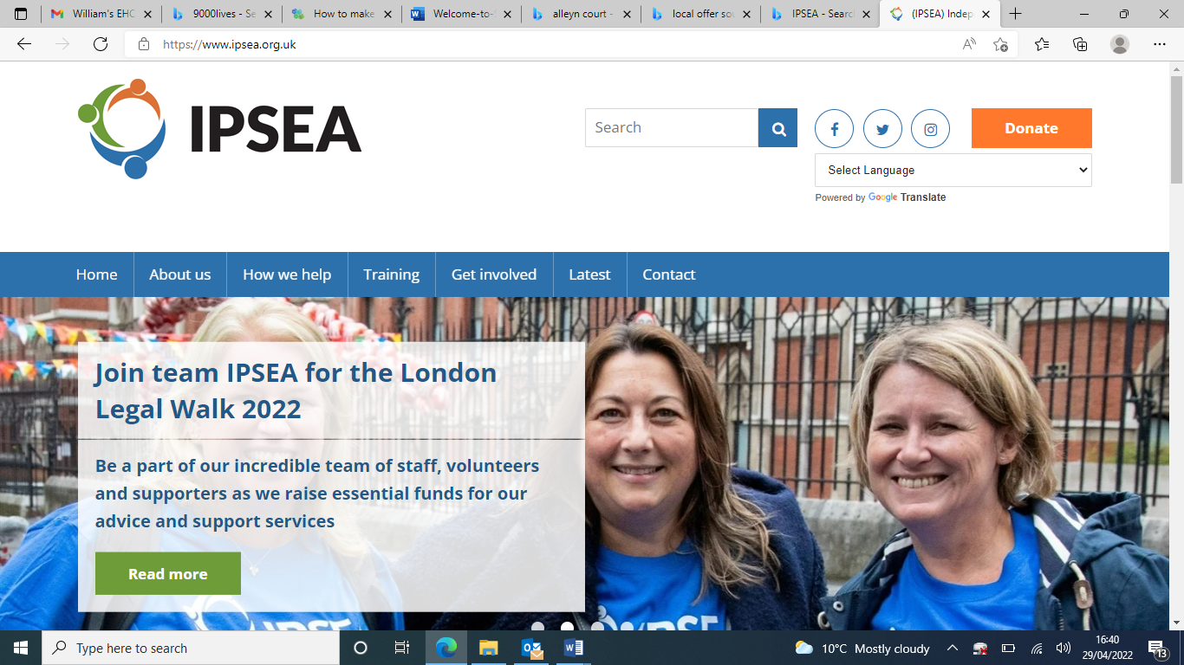

IPSEA is the **I**ndependent **P**rovider of **S**pecial Educational Advice

The service offers free and independent advice to help get the right education for children with SEND.

### How can parents access ISPEA? Speak to an advisor to book a helpline appointment:

* Tel: 01799 582030 (Monday – Friday, 9am – 5pm)
* Email: office@ipsea.net
* Web: [www.ipsea.org.uk](http://www.ipsea.org.uk)
* Facebook: [www.facebook.com/IPSEAcharity/](http://www.facebook.com/IPSEAcharity/)

### The Local Offer: <https://livewellsouthend.com/kb5/southendonsea/directory/localoffer.page>

The Local Offer is a website that is written for parents and families. It helps them know ‘what is out there’ for youngsters with SEND in our local area. It includes:

* Support services
* Health services (e.g. contacts for the NHS speech and language team)
* Schools
* Leisure activities (e.g. SEN sports clubs)
* Contacts for SEN charities

**Our staff, SENDIASS and the Local Offer can all help parents through the SEND maze.**

**The Role of Children**

The role of children is to **do their very best** so that they **learn more, retain more** and **can do more** for the rest of their lives!

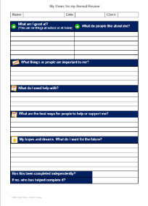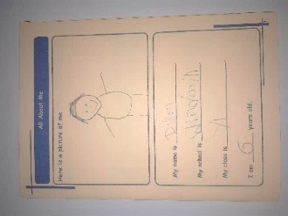It is also important that adults listen to the views of children with SEND. The child’s input can help us unlock extra progress. Collecting child views may include:

* Asking or observing the child.
* The child completing a survey.
* The child self-assessing their behaviour targets.
* The child coming to their SEND review meeting.
* Discussion with the child for their Pupil Passport
* An annual survey of SEND children.

How we collect child views depends on the child’s age and development.

### C**an a child with SEND join in day trips, residential trips and clubs?**

Yes – we make adjustments so that children who have SEND can join in all of school life. This includes trips, residential trips, clubs, school productions and School Council.

Staff may need to talk to parents to plan adjustments. Or, a parent can talk to their class teacher if they are worried that their child might need adjustments to be successful.

It is very rare that we must make the hard decision for a child to not attend – in the very small number of occasions this is due to safety, wellbeing, or both.

## Our Team: Who’s Who?

### Meet our SENDCo: Mrs Nicky Vangalis-Stobbs

* I oversee and co-ordinate SEND provision for children with SEND.
* I support and guide staff and parents so that children with SEND have both high-quality teaching and ambitious support.
* I advise on the use of school’s SEND budget and resources to meet children’s SEND.
* I work with the head teacher to plan how we will enhance our SEND work.
* I identify training needs and make sure that SEND INSET enhances staff skills.
* I liaise with Early Years settings and other schools to help a smooth transition both in and out of our school.
* I am the key contact for external SEND support services.

**Me**et **our Head Teacher: Mrs Hannah Sanders**

* I set an inclusive ethos for the school.
* I lead and manage the staff team, including the SENDCo.
* I check on the quality of education. This includes SEND provision.

## Our Staff – A Whole School Approach

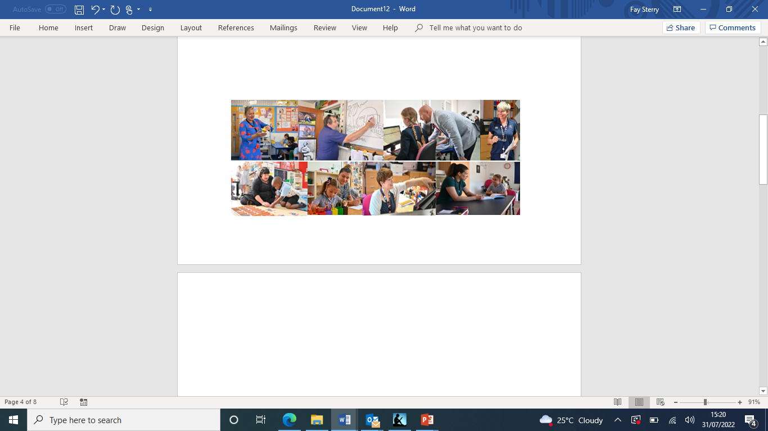

**“Every teacher is a teacher of SEND”**

**“All staff play a role supportingpupils with SEND”**

### What do our teachers do for SEND?

* Teachers are responsible for the development of *every child* they teach.
* Teachers work closely with support staff to plan and review support.
* Teachers adjust lessons to make them accessible for every child.
* Teachers use assessments to plan inclusive lessons.
* Teachers follow advice from any support services.
* Teachers review each child’s progress and plan the next steps.
* Teachers are the first port of call for parents to share concerns over a child’s progress.

### What do **support** staff, including Learning Support Assistants, do?

Learning Support staff are a key part of helping children reach for the stars. They support children during lessons and also lead interventions and programmes for pupils with SEND and provide 1:1 work inside and outside of the classroom.

### Our Trustees

All our governors must “think SEND” when making decisions so that we become even more inclusive. We have one Trustee who has extra responsibilities for pupils with SEND.

**Meet our Trustee for pupils with SEND: Mr Richard Green**



* I oversee long term plans for improving SEND in school.
* I monitor SEND in the school. This includes legal duties.
* I meet with the SENDCo three times a year.

## Staff Training

Our team have lots of SEND expertise. However, it is important we refresh and develop our learning and further develop our skills.



To train and develop our team, we use:

* Staff meeting and INSET day training
* Training sessions delivered by the SENDCo
* Staff sharing ideas, support and practice
* Online courses and webinars
* Online information
* External professionals to provide training sessions

**What training have we had?**

Examples of training for our staff in the past 5 years includes:

**Cognition and Learning**

* Singapore Maths
* Dynamo Maths
* WordWasp
* The Power of Two
* WordShark
* Teaching Children with Specific Learning Difficulties
* Tutoring with the Lightning Squad

Communication & Interaction

* Attention Autism
* Zones of Regulation
* Theory of Mind
* Pathological Demand Avoidance
* Wellcomm (pending)
* Teaching children with Autistic Spectrum Disorder
* Developmental Language Disorder

**Social, Emotional & Mental Health**

* Social Stories
* Incredible 5-point scale
* Zones of Regulation
* Attachment
* Bereavement
* Mental Health First Aid
* Boxall Profile
* Executive Function Skills

**Other**

* Seizure Care Management
* Epipen Training
* Gym Trail
* Fine & Gross Motor Skills
* Duchenne Muscular Dystrophy
* The role of the LSA
* Positive Handling (Team Teach)

If there’s something that’s not on this list, please ask. As this list does not cover every single training session, it’s possible that we have staff trained in the area that you are interested in.

## Can school access specialist help?

Yes. Some students have needs that are very specific or complex. Therefore, we work with support services to benefit from specialist advice. You may sometimes hear us refer to these support services as “external agencies”.

**Support Services we work with include:**

* Educational Psychology Service (EPS)
* CAMHS / EWMHS
* Autism Outreach Service
* Autism Specialists
* Behaviour Outreach Support Service
* Teacher of the Deaf / Visual Impairment Team
* Early Help Team
* Speech and Language Therapists
* Language and Communication Outreach Service
* Occupational Therapists and Physiotherapists
* Child Counsellors and Psychotherapists
* Child Psychiatrists
* Paediatricians
* Specialist Teachers
* Specialist Advisory Services
* Charities

For most children, we meet their SEND without needing external support services or professionals. This is because our staff have training and skills to **adapt classrooms and lessons** to meet their needs.

If we think we ned extra advice from a SEND support service, we discuss this with the child’s parent(s). Parents normally understand the many benefits for their child, but they are welcome to chat with the class teacher or SENDCo. The parent makes the final decision.

Support services advise teachers and the SENDCo. Teachers make sure advice is followed and the SENDCo monitors this.

The school can also carry out initial screenings to assess for indicators for the following barriers to learning: ADHD, Dyslexia, Dyscalculia, cognitive processing, comprehension skill difficulty, speech and language difficulties, mental and emotional health difficulties.

## Transition - When Children Join or Leave Us

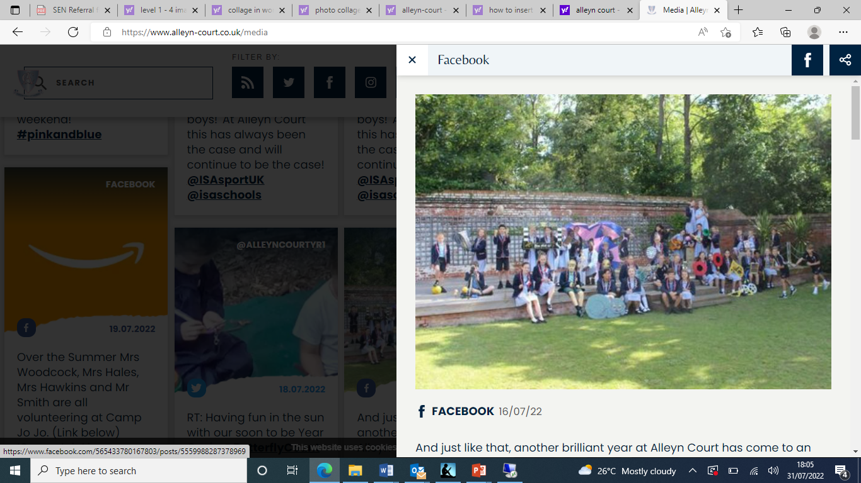

**How do we help children joining our school?**

* We meet parents and any nursery, childminder or current school to find out about the child’s needs.
* We consult any external professional involved with the child
* We ensure paperwork and data from a previous setting is shared with us.
* Where possible, we observe the child in our setting before joining the school
* We provide a Welcome to School booklet.
* The child visits school and gets to meet the adults in their new class.
* The child can have extra visits if needed.

**How do we help children leaving our school?**

* We link with the next school to share SEND information.
* We often support children by accompanying them on extra visits to their new school and talk to children about any worries about their new school.
* Transfer to secondary school is normally led by the secondary school. You can find more about how they manage this in their SEND Information Report.
* Where necessary, we invite the SENDCo of the child’s secondary school to the Y6 summer SEND review.

We take the same approach if a child with SEND leaves our school before the end of Y6 (e.g. because of a house move). If a child moves school quickly or further afield, we may tweak our support (for example, there is not a SEND Review before they move).

**Transition between Year Groups**

Before the end of the summer term, teachers pass on SEND information to the new teacher and the child gets to visit their new class.

If needed, extra visits to the new class or social stories are provided to help children with SEND have a smooth transition to their new class.

## Our School Site

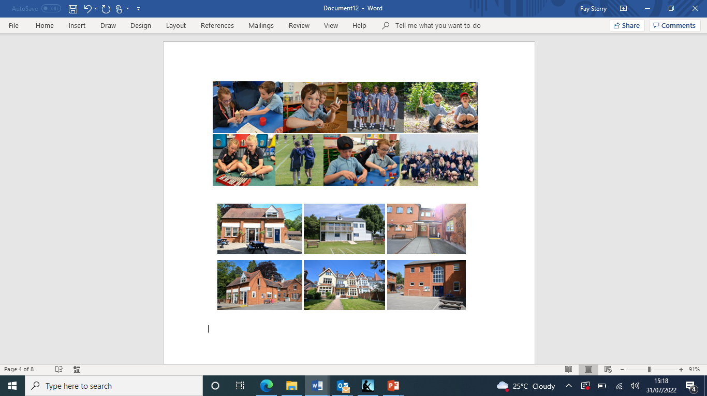

Our school is made up of two parts: Pre-Prep (Early Years – Year Two) and Prep (Year Three to Year Six). The site is made up of the following buildings

* Imperial (Nursery block)
* Wilcox Block (Reception to Year Two)
* Tomlinson Block (Year Three to Six, plus specialist subjects – Art, Music, Computing, French, Science)
* Sports Hall
* Music Room
* The Burrow (SEND and inclusion)
* Dining hall
* Pavilion
* The Looking Glass Library

|  |  |
| --- | --- |
| The Wilcox block has:   * Slope access to the building * An Accessible toilet * Ground floor classroom | The Tomlinson block has:   * A slope to access the building * Two accessible toilets * Ground floor classrooms and an accessible lift to first floor classrooms |

Other areas of the school include:

* Library with step-free access
* Sports Pavilion with access to ground floor changing rooms and toilets
* Sports Hall with accessible toilet and step-free access
* Accessible Music room
* Dining and Assembly hall with step-free access

We have a gated playground/sports court and a sports field, which is also fenced and gated, perfect for games and making friends in the sunshine. We have a large Forest School and an outdoor classroom. All outdoor areas are accessible.

The school site has also been inspected to ensure that it is safe for pupils with visual impairment.

**Extra Equipment for SEND:** Some children need additional equipment to help them access aspects of school life. This is mostly provided by the school but occasionally specialist equipment are required. Occasionally, we may have to might apply for extra funding from the local authority or the loan of equipment from local charities and services. Rarely, parents may be asked to contribute.

## Your Questions Answered

**1. Does a child need a diagnosis in order to have SEND?**

No. Some children do have a diagnosis (e.g. autism, ADHD), but we can address a child’s SEND even if they don’t have a diagnosis.

We know that families often want a diagnosis so that they can be sure what is going on for their child. But, it’s also important that we help the child as soon as we can – so we don’t need to wait for a diagnosis to make adjustments for a child. However, we are not able to confirm whether a child has a diagnosis or add a diagnosis to a child’s support plan without formal assessment from an appropriate medical or external professional.

**2. What is an EHCP?**

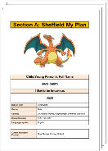EHCP is short for *Education, Health and Care Plan.* Thisis a legal ‘contract’ between a local council, school and parents.

Most children’s SEND can be met without an EHCP. Some of these children will have Individual Support Plans or One Plans (a plan that sets out their needs and how we’ll meet them).

A small number of children with more complex SEND have an EHCP (about 2% of all children, nationally, 1% of pupils in our school). Some of these children are in special schools and some are in mainstream schools.

More information on EHCPs can be found on the Local Offer website or you can ask our SENDCo about EHCPs. Please note, as Alleyn Court Preparatory School is an independent school, our funding structure for SEND differs to that of state schools, therefore parents may be required to contribute towards the funding of their child’s SEND support provision. Please see the school’s Admissions Policy for more information.

**3. Are emotional difficulties always SEND?**No. Some children have time when they are withdrawn or sad (e.g. because of a death of family member or loved pet).

When a child is distressed, this is often short term. We have a range of emotional support we can offer, depending on a child’s difficulties.

Some adverse experiences lead to longer term or more severe emotional issues. If so, the child’s difficulties might be assessed a SEND.

*A Five Point Scale to help children learn about emotions.*

**More Questions Answered**

**4. What support is available for social and emotional needs?**

We are proud to be a caring, nurturing and supportive school. We believe that children need to feel happy, secure and safe in order to meet their potential.

Every child is treated as an individual. If they exhibit challenging behaviour, we try to find the causes and then adapt so we can alleviate the behaviour.

Some of our support is available to all children:

* Class circle time & PSHE lessons
* School assemblies about emotions and feelings
* Posters tell children who they can talk to if worried (our safeguarding team)
* Clear systems for managing behaviour
* Play equipment for children to enjoy at playtime and lunch time
* Staff who offer pastoral support
* Mindfulness club

Some children also have extra support, including:

* Small groups to support social skills
* Boxall Profile targets
* Behaviour Support Plans help some children regulate their emotions.
* Social stories
* CBT-based programmes
* Weekly social or emotional support sessions with the SENDCo

**5. Why don’t schools include a child with autism or ADHD as having a sensory need on the paperwork or the school SEND register?**

Every school must follow the government’s SEND handbook. This is called the SEND Code of Practice. It tells us what categories of SEND we are allowed to use and what each category means.

The government’s category “Physical / Sensory Needs” includes three specific sensory needs:

* Visual impairment: Loss of some or all of their sight;



* Hearing impairment: Loss of some or all of their hearing;
* Multisensory impairment: Loss of some or all of both their hearing & sight.

Each of these sensory needs refers to the loss of sight and/or hearing.

Children with ASC or ADHD can also have sensory needs but they have not lost the use of their senses. It’s more that they might be over or under-sensitive to sights, smells or sounds etc. Their needs are usually about processing of sensory information rather than loss of vision or hearing.

Although we can’t put these needs into the government’s sensory needs category, it doesn’t make a difference to the support that the child receives.

## Additional Support for Pupils with SEND

In addition to High Quality Teaching, we use the following support programmes:

|  |  |  |  |  |
| --- | --- | --- | --- | --- |
| **Programme / Intervention** | **Purpose** | **Frequency** | **Delivered by** | **Duration** |
| **Gym Trail** | To develop gross and fine motor skills | 3 – 5 times per week | Trained Gym Trail LSAs | Usually recommended for one year |
| **Tutoring with the Lightning Squad** | To support pupils with Literacy/difficulties | 3 times per week | SENDCo  Head of English  LSA | Open ended until the pupil has worked through the programme |
| **WordWasp** | To support Literacy/spelling | 4 times per week | LSA trained in WordWasp | Until programme is complete |
| **The Hornet** | To support Literacy/spelling | 4 times per week | LSA trained in The Hornet | Until programme is complete |
| **Power of Two / Plus One** | To support numeracy / Maths | 4 times per week | LSA trained in Po2/Plus One | Until programme is complete |
| **Adapted Maths Teaching** | To support Numeracy learning difficulties | During maths lesssons | Speclialist tutor | Until progress is secure |
| **The 5 Point Scale** | To support pupils with anger management and sensory challenges | As needed | Class / subject teachers / LSA | As long as is needed |
| **Zones of Regulation** | To support pupils with anger management and sensory challenges | As needed | Class / subject teachers / LSA | As long as is needed |
| **Volcano in My Tummy** | To support pupils with anger management challenges | One, 35-minute session per week | SENDCo | Approx eight weeks |
| **CBT Social Support Programme** | To support pupils with social integration difficulties | One, 35-minute session per week | Pastoral Deputy Head and SENDCo | Eight weeks |
| **Social Stories** | To support pupils with ASD to develop social skills and an understanding of the world | N/A | 1:1 ASD Learning Support Tutor | As long as is relevant |
| **ASD Social Support Group** | To support pupils with ASD to develop social skills | One, 35-minute session per week | 1:1 ASD Learning Support Tutor | Reviewed after each term |
| Also: TacPac, Attention Autism, Colourful Semantics  In development: Art and Music therapy; Lego Therapy, Six Bricks | | | | |

**Other Information**

### Exclusions

We reduce the risk of exclusions by making adjustments to help everyone fully access life in school.

However, you can find out more about exclusions in our **Behaviour Policy** on the policies page of our website.

### Monitoring our SEND Strategy

We have five key ways to check how well our SEND strategy is working:

1. Monitoring the progress children have made.



1. Monitoring how well children with SEND meet their SMART targets.
2. Regular reviews of interventions with teachers and support staff.
3. Our leadership team visit classrooms to observe and look through children’s books.
4. Listening to the views of parents, families and children.
5. Weekly meetings between the SENDCo and the leadership team.

Our SENDCo and leadership team are in charge of evaluating our SEND policy.

### Where to find more SEND Information?

Visit our website: www.alleyn-court.co.uk to read other policies that link to SEND:

* **Accessibility plan**

A three year plan to be a more inclusive school.

* **Behaviour Policy**

Rewards, rules, sanctions and much more.

* **Anti-bullying**

Information on our approach to tackling bullying

* **Medical Policy**

Support for children with medical conditions and what we do about medicines.

### Want to read more?

If you want to read more, these are the key SEND rules and laws:

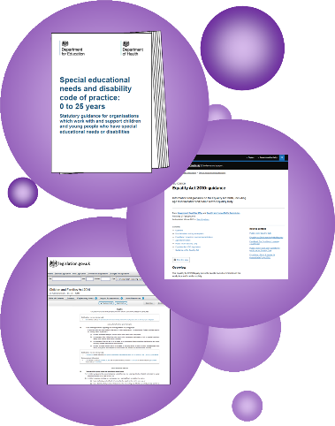

**SEND Code of Practice**

* This is the Government’s SEND rulebook.
* Find out more [here](https://assets.publishing.service.gov.uk/government/uploads/system/uploads/attachment_data/file/398815/SEND_Code_of_Practice_January_2015.pdf).

**Equality Act**

* This 2010 law outlines our duties to make reasonable adjustments and not discriminate.
* Find out more [here](https://assets.publishing.service.gov.uk/government/uploads/system/uploads/attachment_data/file/315587/Equality_Act_Advice_Final.pdf).

**The Children & Families Act**

* This 2014 law outlines our duties for children with SEND.
* Find it [here](https://assets.publishing.service.gov.uk/government/uploads/system/uploads/attachment_data/file/359681/Young_Person_s_Guide_to_the_Children_and_Families_Act.pdf) (p.21 onwards).

### Status of our SEND Policy

This policy is statutory. That means that the law says schools must have a SEND policy and a SEND information report. The DfE say that these can be a single document.

We use a single document so that it is easier to find out about our SEND work. This booklet has all the essential parts of both the SEND Information Report and SEND Policy.

### Evaluating our SEND Policy

The SENDCo and other school leaders have five key ways to check how well our SEND policy is working:

1. Monitoring how much progress children have made.
2. Monitoring how well children with SEND are meeting their SMART targets.
3. Regular reviews of interventions with teachers and support staff.
4. School leaders visit classrooms to observe, or looking through workbooks.
5. Asking parents and children about SEND in our school.

### Reviewing this policy

We review this policy every 12 months. Our SENDCo is in charge of the policy review. Then, our Board of Trustees discuss and approve it.

**We hope you found this SEND document helpful. Thank you for reading.**

**We welcome questions and comments – please get in touch with our SENDCo.**